Name: ___________________________________
Persepolis: The Story of a Childhood, by Marjane Satrapi
Ms. Kamrass; English 9
Essential Questions:
When does childhood end?
How do people react to tragedy and trauma?
Persepolis is a graphic novel. Why do you think Satrapi chose this genre to tell her story? What do you expect from it, as opposed to a regular novel?
Literary terms:
allusion - In literature, an implied or indirect reference to a person, event, or thing or to a part of another text. Most allusions are based on the assumption that there is a body of knowledge that is shared by the author and the reader and that the reader will understand the author's referent.
dialogue – lines spoken by characters in a literary text
graphic novel – a full-length novel that presents subject matter in comic-book form. Oftentimes graphic novels tackle serious subjects (as opposed to regular comic books).
Terms and Concepts for Graphic Novels
panel – a distinct segment of the comic, containing a combination of image and text in endless variety.
frame – the lines and borders that contain the panels.
gutter – the space between framed panels
figures - Faces can portray different things: some depict a specific character, others can represent an idea, or group of people.
Text has two forms:
captions – these are boxes containing a variety of text elements. They can add narration, or describe the physical setting or the scene.
speech balloons – these enclose dialogue that comes from a specific speaker’s mouth. These can show external dialogue, or internal thoughts (usually represented by circles that lead to the balloon).
Persepolis

Persepolis was the ceremonial capital of the Persian Empire during the Achaemenid dynasty.

The setting for the story is NOT Persepolis; it is Tehran.
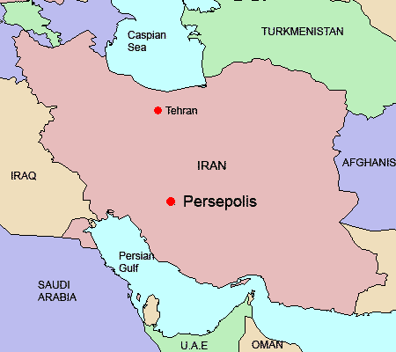

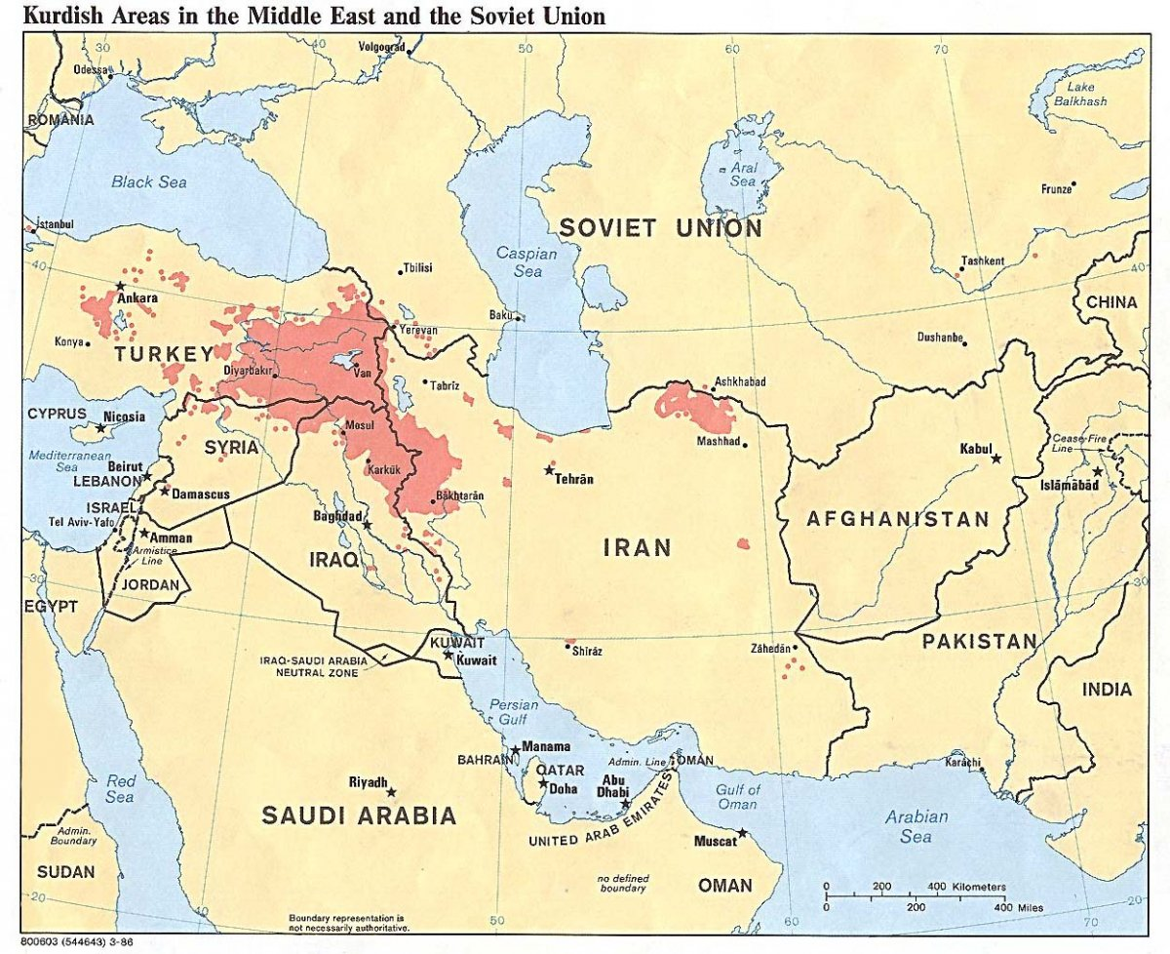

This is a map showing proximity of Iran to communist Russia (U.S.S.R.) as it was during the setting of the novel (late 1970s-early 1980s).
Persepolis Chapter Questions
“Introduction”
- According to the introduction, what stereotypical image is Satrapi trying to dispel?

- The author indicates some motives for writing Persepolis: What are they?

- The previous page of this study guide tells you what Persepolis is. Why do you think it is the title of Satrapi’s autobiography?

Teacher note before reading:
The first few chapters -- and even the events within some chapters -- are not arranged chronologically. For her exposition, Satrapi chose to highlight events that have the most impact on her story, instead of arranging them according to the time that they took place. Keep this in mind as you read: you may be a little confused, but that is natural. Reread portions to clear the confusion. Soon you will notice that the flashbacks become clearer to you.
In addition, Satrapi makes many references to historical, political, and religious figures. Oftentimes, she explains who they are in the text, but I have also included some definitions by chapter to help clarify. This book can be difficult, but I love that it helps broaden your education beyond English language arts!

“The Veil”
Islamic Revolution – Iran 1979 – a state of revolt when the Iranian Shah was overthrown and an Islamic theocracy was put in place.
Zarathustra -6th century B.B., Persian religious teacher.
1. Write down your questions after reading this chapter. What confuses you?
2. Write three important points that you learn about Marjane (or Marji) after this chapter. Use at least one quote and include the page number.

“The Bicycle”
Fidel Castro - A Cuban political leader of the twentieth century. He led the revolution that in 1959 overthrew the dictator of Cuba, who had the support of the United States. Castro then presided over his country's transformation into a communist state.

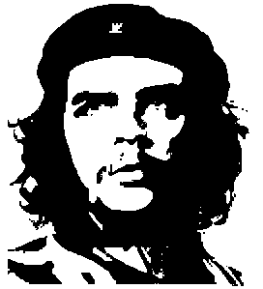Che Guevara - Theoretician and tactician of guerrilla warfare and prominent figure in Fidel Castro's revolution in Cuba (1956–59).

Trotsky, Leon, 1879-1940, Russian Communist revolutionary, one of the principal leaders in the establishment of the USSR

Shah - (formerly, in Iran) king; sovereign.
tyranny – a government in which one ruler has absolute power
communism – a government system that eliminates private property and provides a system to share common goods
socialism – economic and political theory that calls for the state – government in charge – to own and control production and distribution of goods, among other things. Socialists are people who belong to a socialist political party, or who favor its theory. This theory is different from ours: capitalism (an economic system where private parties – not the government – control economic distribution of goods, production, pricing and other factors present in a free market).
Marx – Karl Marx, an eighteenth century, German philosopher who wrote several texts – including The Communist Manifesto – to educate people about communism (see above).
Descartes – René Descartes: a philosopher, mathematician and scientist who lived until the beginning of the seventeenth century.
BBC – The British Broadcasting Corporation: Marji’s parents often watch these reports on TV, or the radio to receive information that is free of bias – and some outright lies – present in the Iranian broadcasts.
dialectical materialism – A complex philosophy derived, in part, from the writings of Karl Marx.
3. What happens at the Rex Cinema? Who is responsible for what happens, according Marji’s parents?

4. What happens to Marji’s relationship with God in this chapter?

“The Water Cell”
republic – A government that relies on a citizens who elect representatives. In addition, there is usually a president, as opposed to a monarch.

theocracy – a form of government in which God or a deity is recognized as the supreme civil ruler, the God's or deity's laws being interpreted by the ecclesiastical authorities

Lenin – Vladimir Lenin, who founded the Russian Communist Party (Bolsheviks) and staged a successful communist revolution in 1917. He was the first head of the Soviet state until his death in the early twentieth century.

5. What is Marji’s father’s reaction to her proclamation that the Shah is chosen by God? What does he reveal about the Shah and Marji’s grandfather?

6. Describe two things that Marji’s mother describes in the flashback.

“Persepolis”
Cyrus – Cyrus the Great (or Cyrus II), king of the Achaemenian empire – is modern-day Iran – who died in 580 B.C. Cyrus exists in both history and myth.

martyr – A martyr is someone who dies for a cause. Originally, it was term that related to people who were executed for religious beliefs, but is now used to describe someone who dies for a variety of reasons (political, etc.).

7. What does Marji learn about the Shah, from her grandmother?

8. Where was Marji’s father and why is he in danger? What does this tell you about the government?

“The Letter” – read in class
Charles Dickens – A nineteenth century British author who wrote stories highlighting the problems of the poor, and distinctions between social classes. Some of his books include Great Expectations, Oliver Twist, and Nicholas Nickleby.

social class – A social class can be described as a group that shares the same economic similarities. In our country – as well as others – some groups include the middle class, upper-middle class, lower class, etc.; for these terms, their definition is tied directly to economic status. More recently, this division has been described as the ninety-nine percent as opposed to the one percent.

9. Why wouldn’t a relationship work between Mehri and her “boyfriend,” according to Marji’s father?

10. Why is his view ironic (from #9)? Remember his political ideology: Marji even reminds him of this.

11. At the end, Marji says, “our own…had attacked us.” Given what has gone on throughout the chapter, describe the double meaning in “our own.”

“The Party”
12. This is the first time that there is reference to the United States. What had changed in our country’s relationship with Iran?

13. Look at the entire illustration in the second-to-last panel on p. 43. What does it seem to suggest despite what Marji and her family are saying?

“The Heroes”
14. Where had Siamak and Mohsen been for the last several years? Why?

15. Who led the training in torture practices?

“Moscow”
16. Why does Marji consider Anoosh to be a hero? Why do you think she loves him so much?

“The Sheep”
18. What is the significance of the title? How does term’s symbolism characterize the people of Iran?

“The Trip”
19. What do the fundamentalist students do? How does this event affect Marji’s plans?

For chapters without any questions, your homework will be based on your response to the text. These responses need to include: Confusion, Comments, Quotes (complete with page number and analysis), Questions, Comments and Key illustrations.
“The F-14’s”
Model it here for students
“The Jewels”

“The Key” – read in class
20. This chapter also provides a symbolic key to the trouble that we see today with terrorism and suicide bombings. Explain the connection.

“The Wine”
“The Cigarette”
“The Passport”
“Kim Wilde”
“The Shabbat”
“The Dowry”

21. How did Marji’s life change after Neda’s death? What happened at school?

22. What did Satrapi learn about the government in her new school? How did she respond?

23. How does Marji’s dad respond to her behavior at school? Her mom? Why?

24. What happened to Niloufar? Why? How do you know? What is Marji’s reaction?

25. Where do Marji’s parents decide to send their daughter? Why? What is Marji’s
reaction?

26. What is a “dowry”? Why is it the title of this chapter?

